Project TeamWalkers Final System Testing Document

Team TA082 Force for Workers

Sri Nehallika Atluri, James Hill, Kai Huang, Tiange Yang

# Usability Testing

Link to most recent usability test video (for Iteration 3): <https://youtu.be/gNOdZUo4wBk>

# Compatibility Testing

**Compatibility Testing**

|  |  |  |
| --- | --- | --- |
| **Browser/Device** | **Compatible?** | **Testing Artefact** |
| Firefox/Windows PC | Yes |  |
| Chrome/Windows PC | Yes |  |
| Edge/Windows PC | Yes |  |
| Chrome/Android phone | Yes |  |

# Unit/Functionality Test Cases

**Title: Check activity and nutrition using valid inputs**

**Description:** The user checks their current daily activity and diet against the targets for healthy living using reasonable numbers.

*Assumptions*: The user is able to recall the general amount of time they’ve spent walking and what they’ve eaten.

*Preconditions*: The user is on the page www.teamwalkers.tk/?page_id=1749

|  |  |
| --- | --- |
| **Test Steps** | 1. For the first question, “How much time have you spent walking or doing some other exercise today?”, the user enters: 18 |
| 2. For the second question, “How much fruit have you eaten at work today?”, the user enters: 1 |
| 3. For the third question, “How many vegetables have you eaten at work today?”, the user enters: 2 |
| 4. For the fourth question, “How many high-fat or high-sugar foods have you eaten at work today?”, the user enters: 1 |
| **Expected Result** | The user’s percentage progress toward each daily target is indicated to them, they are encouraged and provided suggestions to keep improving. |
| **Actual Result** |  |

**Title: Check activity and nutrition using invalid inputs**

**Description:** The user checks their current daily activity and diet against the targets for healthy living using invalid values.

*Assumptions*: The user is able to recall the general amount of time they’ve spent walking and what they’ve eaten.

*Preconditions*: The user is on the page www.teamwalkers.tk/?page_id=1749

|  |  |
| --- | --- |
| **Test Steps** | 1. For the first question, “How much time have you spent walking or doing some other exercise today?”, the user enters: -5 |
| 2. For the second question, “How much fruit have you eaten at work today?”, the user enters: 50 |
| 3. For the third question, “How many vegetables have you eaten at work today?”, the user enters: salami! |
| 4. For the fourth question, “How many high-fat or high-sugar foods have you eaten at work today?”, the user enters: five |
| **Expected Result** | The user is presented with messages informing them to only enter a positive number or that the number they’ve entered is too high and they may have made a mistake. |
| **Actual Result** |  |

**Title: Centring the map on the user’s location.**

**Description:** The user shares their location and the Google maps element zooms and centres on their location and sets it as the start and end route for walking routes.

*Preconditions*: The user is on the page <https://www.teamwalkers.tk/?page_id=154>

|  |  |
| --- | --- |
| **Test Steps** | 1. The user accepts the website request to share their location. |
| **Expected Result** | The map zooms and centres on the location of the user. |
| **Actual Result** |  |

**Title: Centring the map on an address**

**Description:** If a user does not want to share their location, they can enter an address which will then be centred and used as the point for walking routes.

*Preconditions*: The user is on the page <https://www.teamwalkers.tk/?page_id=154>

|  |  |
| --- | --- |
| **Test Steps** | 1.The user declines the request to access their location. |
| 2. The user searches for a valid address within the City of Melbourne - “181 WIlliam St Melbourne” |
| **Expected Result** | The map zooms and centres on the location. |
| **Actual Result** |  |

**Title: Providing an invalid address**

**Description:** If a user does not want to share their location, they can enter an address which will then be centred and used as the start and end point for walking routes.

*Assumptions*:

*Preconditions*: The user is on the page <https://www.teamwalkers.tk/?page_id=154>

|  |  |
| --- | --- |
| **Test Steps** | 1.The user declines the request to access their location. |
| 2. The user searches for an invalid address - “123 Fake St Melbourne” |
| **Expected Result** | No result is displayed, and the map remains in its previous position. |
| **Actual Result** |  |

**Title: View nearby walking destinations**

**Description:** The walk mapping tool will automatically update the destinations displayed within the specified distance from the user.

*Assumptions*: The user has shared their location and is within the City of Melbourne or has manually set their location within the City of Melbourne.

*Preconditions*: The user is on the page <https://www.teamwalkers.tk/?page_id=154>

|  |  |
| --- | --- |
| **Test Steps** | 1. The user selects a type of destination: Public art |
| 2. The user then selects the sub-type: Monument |
| 3. The user selects the distance “1000m” from their location within which they want to search from the distance drop-down menu. |
| **Expected Result** | The map automatically updates with each selection to show the destinations. Matching destinations listed in the right-hand panel are also automatically updated. |
| **Actual Result** |  |

**Title: Create a walking route**

**Description:** The user selects a location marked on the map and has a walking route generated and presented to them along with directions.

*Assumptions*: The user has shared their location and is within the City of Melbourne or has manually set their location within the City of Melbourne.

*Preconditions*: The user is on the page <https://www.teamwalkers.tk/?page_id=154> and has set criteria to display walking destinations within a certain radius

|  |  |
| --- | --- |
| **Test Steps** | 1. The user selects a marker on the map by clicking on it on the map or selecting a destination from the list in the side panel. |
| **Expected Result** | The map zooms and centres on the walking route which is presented visually. Directions are displayed in the bottom right hand panel. Nearby destinations are updated for the user to select a route to another landmark or public artwork. |
| **Actual Result** |  |

**Title: Complete the sitting habits quiz and access the guide**

**Description:** The user answers some questions to gauge the healthiness of their workplace habits and the proceeds to the quiz.

*Preconditions*: The user is on the page <http://www.teamwalkers.tk/>

|  |  |
| --- | --- |
| **Test Steps** | 1. The user clicks the button with the prompt “HOW HEALTHY ARE YOUR WORK HABITS?” and is moved to the quiz page. |
| 2. The user selects “2-4 hours” for the first question and the screen automatically scrolls to the second question. |
| 3. The user selects “6-8 hours” for the second question. |
| 4. The message “You might have unhealthy sitting habits. Learn more from our handy guide.” Appears. |
| 5. The user clicks the button labelled “Learn more”. |
| **Expected Result** | The Health and Wellbeing Guide page is displayed to the user. |
| **Actual Result** |  |

**Title: Interact with data visualisations in the health guide**

**Description:** The user can inspect elements of the data visualisations and refine what is shown in the visualisations down to what they’re interested in.

*Assumptions:*

*Preconditions*: The user is on the page <http://www.teamwalkers.tk/?page_id=10>

|  |  |
| --- | --- |
| **Test Steps** | 1. The user views the “prevalence of physical inactivity based on age and sex” visualisation. |
| 2. The user deselects “total” in the “measure names” drop-down menu |
| 3. The user deselects “all” in the “age” drop-down menu and then selects “25-34 years” and 35-44 years” |
| **Expected Result** | The graph now only displays the prevalence of physical inactivity in the 25-34 and the 34-44 age brackets for males and females. |
| **Actual Result** |  |

**Title: Access facts sheets**

**Description:** Each fact sheet is accessible from the fact sheet hub and via the navigation panel at top and bottom of each fact sheet page.

*Assumptions:*

*Preconditions*: The user is on the page <http://www.teamwalkers.tk/>

|  |  |
| --- | --- |
| **Test Steps** | 1. Select the fact sheets button on the home page or from the drop-down under the guide on the top bar menu. |
| 2. Select the “unhealthy work habits” fact sheet. |
| 3. Once on the “unhealthy work habits” fact sheet, select the “improving wellbeing” fact sheet from the navigation panel at the bottom of the page. |
| 4. Repeat for all fact sheets. |
| **Expected Result** | Each fact sheet should display when clicked on from the hub or from the navigation panels. |
| **Actual Result** |  |

**Title: Download a fact sheet**

**Description:** A print-friendly PDF version of each fact sheet can be accessed by clicking the download button at the bottom of the page.

*Assumptions:*

*Preconditions*: The user is on the “improve your wellbeing” fact sheet page <http://www.teamwalkers.tk/?page_id=713>

|  |  |
| --- | --- |
| **Test Steps** | 1. The user scrolls down and clicks “download” |
| **Expected Result** | A new tab is opened, displaying the PDF version of the fact sheet. |
| **Actual Result** |  |

# Load Testing

Load testing has been conducted on the TeamWalkers but has necessarily been limited by how much of this kind of testing can be conducted without payments or subscriptions.

Ideally, further load testing should be conducted using a larger number of virtual clients querying the site and accessing the maps tool to test how it holds up under stress.

Below are the summary results of the TeamWalkers load test run using WebLOAD.

**TeamWalkers Load Test - Total**

|  |  |  |  |  |  |  |  |  |  |  |
| --- | --- | --- | --- | --- | --- | --- | --- | --- | --- | --- |
| **Start** |  | 10/5/18 9:59 AM |  | **End** |  | 10/5/18 10:19 AM |  | **Duration** |  | 00:20:07 |

|  |  |  |  |  |
| --- | --- | --- | --- | --- |
| **Test passed** | **Max Virtual Clients** | 50 | **Total Throughput (MB)** | 1,272.56 |

|  |  |  |  |  |  |  |  |  |
| --- | --- | --- | --- | --- | --- | --- | --- | --- |
| **Total Errors** |  | 0 |  | **Total Warnings** |  | 1,354 |  |  |
|  |  |  |  |  |

|  |  |  |  |  |  |  |  |  |
| --- | --- | --- | --- | --- | --- | --- | --- | --- |
| **Failed Rounds** |  | 0 |  | **Total Rounds** |  | 251 |  |  |
|  |  |  |  |  |

|  |  |  |  |  |  |  |  |  |
| --- | --- | --- | --- | --- | --- | --- | --- | --- |
| **Total Failed Hits** |  | 0 |  | **Total Hits** |  | 120,865 |  |  |
|  |  |  |  |  |

|  |  |  |  |  |  |  |  |  |
| --- | --- | --- | --- | --- | --- | --- | --- | --- |
| **Total Failed TXs** |  | 0 |  | **Total TXs** |  | 0 |  |  |
|  |  |  |  |  |

**Response Time**

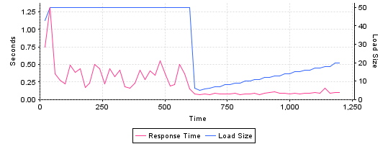

**Hits per second**

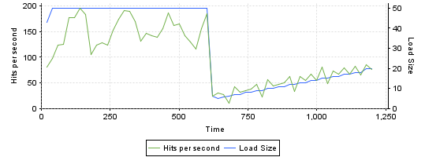

**Throughput**

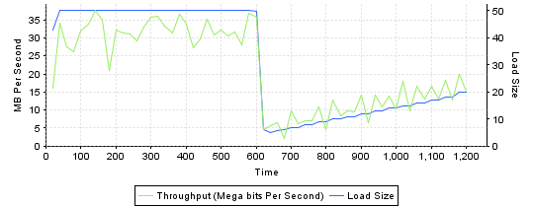

**Warnings**

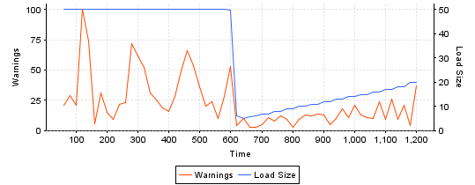

**Agendas Running**

TeamWalkers Load Test